Allerdale Local Plan (Part 2)

Main Modifications Consultation September 2019

Representation Form

Please complete a separate representation form for each Main Modification you wish to comment on. Representations must be made in writing, using the comments form, and sent either by email or post to:

By post: Planning Policy, Allerdale Borough Council, Allerdale House, Workington CA14 3YJ

By email: siteallocations@allerdale.gov.uk

Telephone: 01900 702790

Please return no later than 4 pm on Friday 1 November 2019

Allerdale Borough Council is now seeking representations on the Main Modifications and Policies Map changes only, and no other aspects of the plan. The changes are proposed by the Council to address issues of legal compliance and soundness and only representations on these matters will be accepted. All representations will be forwarded to the Inspector who will consider them prior to issuing his report on the Plan. By submitting this form you are consenting to your personal information and representations being stored and used for this purpose. All representations will be published with personal details such as email address and telephone number being removed.

Further guidance is available online at www.allerdale.gov.uk/siteallocations, or by contacting the Planning Policy Team

“Allerdale – a great place to live, work and visit”

(For official use only)
Consultee
MM Policy Elem.

Date

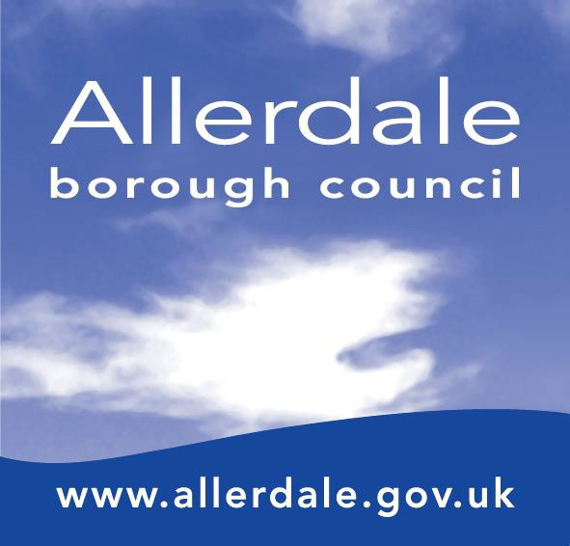ID
Sound
Rec.

Part A: Personal details
*if an agent is appointed, the contact details of both parties must be completed.

 | Personal details | Agent’s details  (if applicable)*
Title
First name
Last name
Job title
(if applicable)
Organisation (if applicable)
Address
Postcode
Tel Number
Email

Please indicate if you wish to be notified of any of the following:

Publication of the inspectors’ recommendations
Adoption of the Local Plan Part 2
Other planning policy and Local Plan news

If you have provided an email address our default is to update you electronically.

2

Part B: Your Representation

To which proposed change (Main Modification Number) does this representation relate?

Main Modification  Number: |  | Paragraph: |  | Policy: |  | Map:

- Do you consider the Main Modification makes the Development Plan Document legally compliant?

Yes |  | No

- Do you consider the Main Modification makes the Development Plan Document:

Sound |  | Unsound

If you have selected unsound, do you consider it:
(1) has not been positively prepared – the plan should be prepared based on
a strategy which seeks to meet objectively assessed development and infrastructure requirements
(2) is not justified – the plan is the most appropriate strategy, when considered
against the reasonable alternatives, based on proportionate evidence.
(3) is not effective – the plan should be deliverable over its period and based
on effective joint working on cross-boundary strategic priorities.
(4) is not consistent with national policy – the plan should enable the
delivery of sustainable development in accordance with the NPPF.

- Please give details of why you consider it to be unsound, not legally compliant, or why you support it. Please be as precise as possible.

(Continue on a separate sheet/expand box if necessary)

- Please set out what change(s) you consider necessary to make the modification legally compliant or sound. It will be helpful if you are able to put forward your suggested wording of any proposal or text. Please be as precise as possible.

(Continue on a separate sheet/expand box if necessary)
Your representation should cover succinctly all the information, evidence and supporting
information to support/justify the representation and the suggested change.

Signature: |  | Date:

Please note that there is a separate representation form for comments on the Habitats Regulations Assessment and Sustainability Appraisal Addendums.

4

