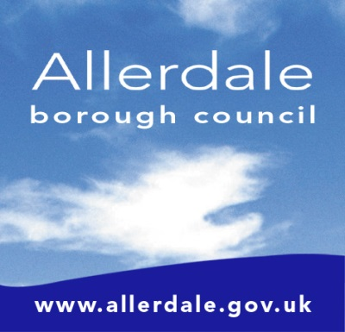

Community Governance Review for Flimby/Maryport

Formal Consultation Questionnaire

Allerdale Borough Council received a petition from the residents of Flimby to conduct a Community Governance Review proposing the creation of Flimby Parish Council.

The written request is below,

‘We the undersigned residents of Flimby want community representation and to have the opportunity to influence decisions within our ward and to have local input with the running of the area in which we live and to implement our own independent Parish Council’

‘We therefore request Allerdale Borough Council to conduct a community governance review of the Flimby ward of the Maryport Town Council area’.

- Are you in support of the creation of Flimby Parish Council or would you prefer to remain under the Governance of Maryport Town Council?
(The area of the potential Flimby Parish Council will be the existing Flimby Ward of Maryport Town Council) – See map overleaf

YES, I support the creation of Flimby Parish Council

NO, keep Flimby as part of Maryport Town Council

UNDECIDED

- Please provide reasons for the above and/or further comment below (please turn over if necessary)

- What is your interest in this Community Governance Review?

  - Resident of Flimby
  - Resident of Maryport
  - Other – Please specify (for example, Business Owner in Maryport or Flimby)

__________________________________________________________________________________

- Please can you provide your home postcode

__________________________________________________________________________________

Please can you return your completed survey to
CGR
Electoral Services
Allerdale Borough Council
Workington
CA14 3YJ

Alternatively, you can complete online at
www.allerdale.gov.uk/en/elections/community-governance-reviews

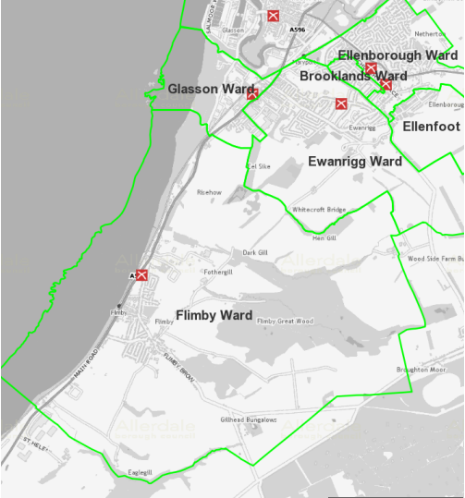
Map of Proposed Flimby Parish Council

Further Comments

__________________________________________________________________________________

__________________________________________________________________________________

__________________________________________________________________________________

__________________________________________________________________________________

Please note, all published responses will be anonymous, Further information is available at https://www.allerdale.gov.uk/en/privacy-policy/

