Gender Pay Gap Report 2021
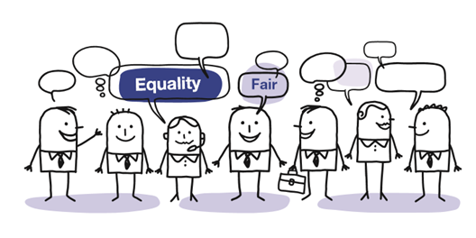

Introduction
From 2017, any organisation that has 250 or more employees must publish and report specific figures about their gender pay gap. The gender pay gap is the difference between the average earnings of men and women, expressed relative to men’s earnings.
All public sector employers are required to publish their gender pay gap information by 30 March each year based on a snapshot date of the previous 31 March (giving a full year to extract, analyse and report).
The gender pay gap is not to be confused with equal pay, which is the right for men and women to be paid the same rate when doing the same or equivalent work. The gender pay gap is concerned with differences in the average earnings of men and women, regardless of their role or seniority. It is, therefore, a broader measure capturing not simply any equal pay issues within an organisation, but also any pay inequalities resulting from differences in the sorts of jobs performed by men and women and the gender composition of the workforce by seniority.
Allerdale Borough Council (ABC) actively encourages a healthy work-life balance and promotes a flexible approach to work to accommodate this. This is reflected in the high level of part-time working across all grades by both genders. The Council promotes diversity, equality of opportunity and choice for our community and employees.

Factors affecting the gender pay gap
The causes of the gender pay gap are many and varied. They often overlap and are frequently outside the control of any one employer.
An organisation with a higher proportion of men in senior roles and women in junior roles will have a gender pay gap. So too will an organisation with a higher proportion of men than women in better-paid functions such as IT and other science, technology and engineering roles.
Women also make up three-quarters of the part-time workforce, whose hourly pay rates tend to be significantly lower than those of full-time workers. In addition, women are much more likely to take time out of the labour market for family reasons, slowing the pace at which they typically progress to more senior and better-paid roles.

Workforce Summary
Nationally local government employs over 1.5 million people – 78% of these are females.
The total number of employees for inclusion in the 2020 reporting information was 240 and the workforce split remained broadly comparable with reporting information (66% female and 34% male).

Figure 1: Gender breakdown of the current workforce
66% 34%

What we have to report
Mean gender pay gap: the difference between the mean hourly rate of pay of male full-pay relevant employees and that of female full-pay relevant employees.
Median gender pay gap: the difference between the median hourly rate of pay of male full-pay relevant employees and that of female full-pay relevant employees.
Mean bonus gap: The difference between the mean bonus paid to male relevant employees and that paid to female relevant employees.
Median bonus gap: The difference between the median bonus paid to male relevant employees and that paid to female relevant employees.
Bonus proportions: The proportions of male and female relevant employees who were paid bonus pay during the relevant period.
Quartile pay bands: The proportions of male and female full-pay relevant employees in the lower, lower-middle, upper middle and upper quartile pay bands.

Gender Pay Gap 31 March 2020

Figure 2: Mean (average) 31 March 2020
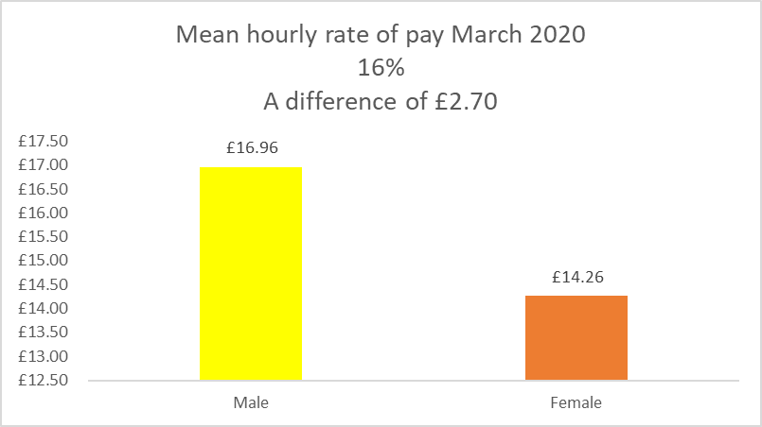

Figure 3: Median (middle) 31 March 2020
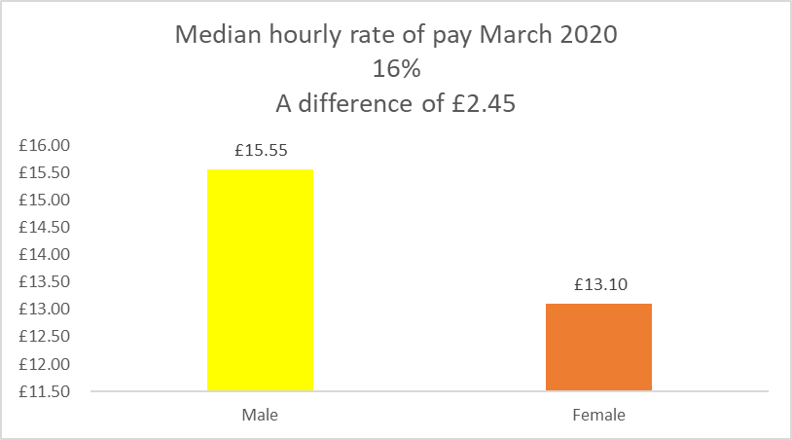
On average for every £1.00 that a male employee earns a female earns £0.84.

Table 1: Bonus Gender Pay March 2020
Bonus Gender Pay Gap | Mean Bonus Rate | Median Bonus Rate
Male | 0 | 0
Female | 0 | 0
Gender Pay Gap | 0 | 0

Table 2: Quartile Pay Bands 31 March 2020
Quartile | Males | Females | Description
1 | 20% | 80% | Includes all employees whose standard hourly rate places them at or below the lower quartile.
2 | 32% | 68% | Includes all employees whose standard hourly rate places them above the lower quartile but at or below the median
3 | 35% | 65% | Includes all employees whose standard hourly rate places them above the median but at or below the upper quartile
4 | 50% | 50% | Includes all employees whose standard hourly rate places them above the upper quartile
The Council is committed to the principle of equal opportunities and equal treatment of all employees. We have a clear policy of paying employees equally for the same or equivalent work, regardless of their sex (or any other protected characteristic). As such we have a pay and grading structure agreed with Unison; have a published pay policy statement; evaluate all jobs using the North West Employers Organisation (NWEO) Job Evaluation (JE) scheme for Chief Officers and the National Joint Council (NJC) job evaluation scheme for all other employees.
The Council is confident that its gender pay gap does not stem from paying men and women differently for the same or equivalent work. Rather its gender pay gap is the result of the roles in which men and women work within the organisation and the salaries that these roles attract.

Analysis of the data
Figure 1 shows that the Council’s gender split is 66% female and 34% male overall (similar proportions to those seen across most areas of local government). However, this gender split is not evenly spread throughout all the grades within the Council - as can be seen from the information at Table 2. This table shows that the proportion of females is much higher in the lower, lower-middle, upper middle quartiles and this distorts the overall mean and median figures for male and female pay. There has been in an increase in females in the lower and upper middle quartile and a decrease in the females in the lower middle quartile (Figures 2 and 3).
The Council does not have provision for the payment of bonuses within its terms and conditions. (Table 1)
During the year to March 2020 the profile of new recruits was slightly imbalanced with 60% female recruits and 40% male recruits. In contrast there were 41% female leavers and 59% male leavers.
In comparison to last year’s published figures there has been a positive change to the gender pay gap which can be seen in both the mean hourly rate of pay and the median hourly rate of pay figures showing that the gender pay gap has decreased in Allerdale Borough Council.

Comparison of mean and median
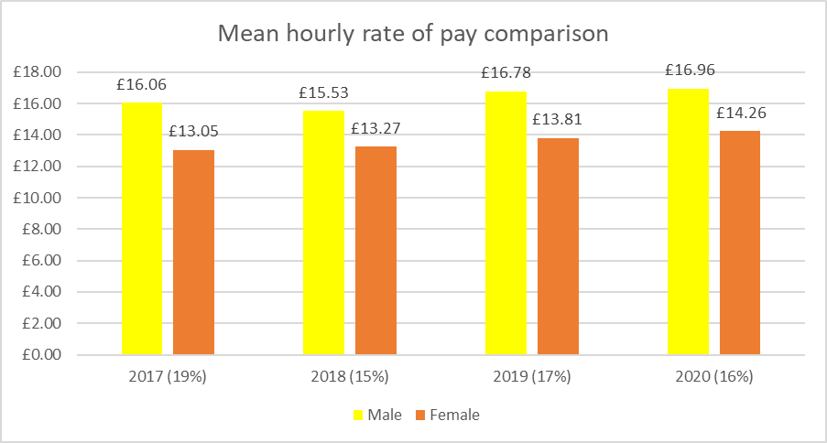

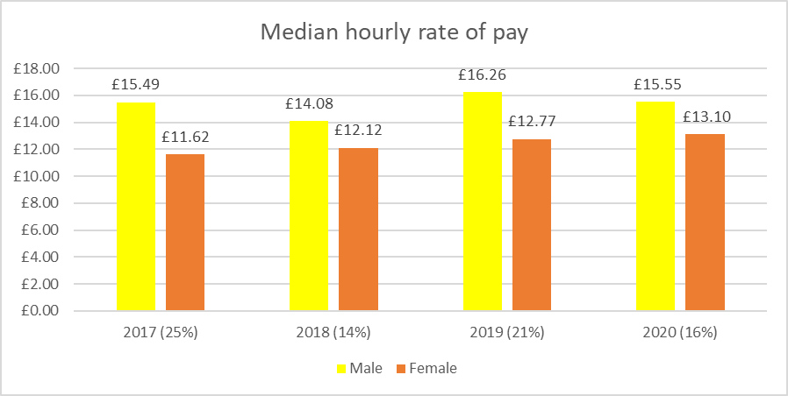

Comparison of quartiles
Quartile | Males 2017 | Females 2017 | Males 2018 | Females 2018 | Males 2019 | Females 2019 | Males 2020 | Females 2020
1 – Lower quartile | 26% | 74% | 32% | 68% | 27% | 73% | 20% | 80%
2 – Lower middle quartile | 24% | 76% | 25% | 75% | 23% | 77% | 32% | 68%
3 – Upper middle quartile | 32% | 68% | 40% | 60% | 43% | 57% | 35% | 65%
4 – Top quartile | 56% | 44% | 48% | 52% | 50% | 50% | 50% | 50%

Quartile - Description
Quartile | Description
1 – Lower quartile | Includes all employees whose standard hourly rate places them at or below the lower quartile.
2 – Lower middle quartile | Includes all employees whose standard hourly rate places them above the lower quartile but at or below the median
3 – Upper middle quartile | Includes all employees whose standard hourly rate places them above the median but at or below the upper quartile
4 – Top quartile | Includes all employees whose standard hourly rate places them above the upper quartile

What is Allerdale Borough Council doing to address its gender pay gap?
Allerdale Borough Council is committed to the principle of equal opportunities and equal treatment for all employees, regardless of sex, race, religion or belief, age, marriage or civil partnership, pregnancy/maternity, sexual orientation, gender reassignment or disability. It has a clear policy of paying employees equally for the same or equivalent work, regardless of their sex (or any other characteristic set out above). As such, it evaluates job roles and pay grades using the NJC job evaluation scheme to ensure a fair and consistent pay structure.
Allerdale Borough Council is therefore confident that its gender pay gap does not stem from paying men and women differently for the same or equivalent work. Rather its gender pay gap is the result of the roles in which men and women work within the organisation and the salaries that these roles attract.
The Council is not complacent in looking at ways to reduce the gap, and it is committed to further reducing the gap.

