

**Gender pay gap report**

**March 2018**

“Allerdale – a great place to live, work and visit”

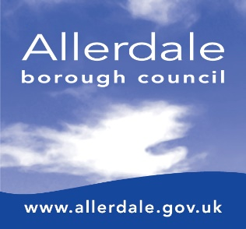

**Introduction**

From 2017, any organisation that has 250 or more employees must publish and report specific figures about their gender pay gap. The gender pay gap is the difference between the average earnings of men and women, expressed relative to men’s earnings.

All public sector employers are required to publish their gender pay gap information by 30 March each year based on a snap shot date of the previous year at 31 March.

**What we have to report**

**Mean gender pay gap:** the difference between the mean hourly rate of pay of male full-pay relevant employees and that of female full-pay relevant employees.

**Median gender pay gap:** the difference between the median hourly rate of pay of male full-pay relevant employees and that of female full-pay relevant employees.

**Mean bonus gap:** The difference between the mean bonus paid to male relevant employees and that paid to female relevant employees.

**Median bonus gap:** The difference between the median bonus paid to male relevant employees and that paid to female relevant employees.

**Bonus proportions:** The proportions of male and female relevant employees who were paid bonus pay during the relevant period.

**Quartile pay bands:** The proportions of male and female full-pay relevant employees in the lower, lower-middle, upper middle and upper quartile pay bands.

**Workforce Summary**

Nationally local government employs over 1.5 million people – 78% of these are females.

At Allerdale Borough Council the total workforce comprises of:

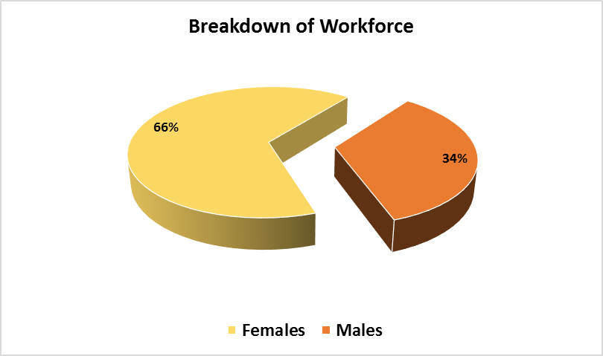

**Gender pay gap (at 31 March 2017)**

**Mean gender pay gap and hourly rate of pay**

**Table 1**

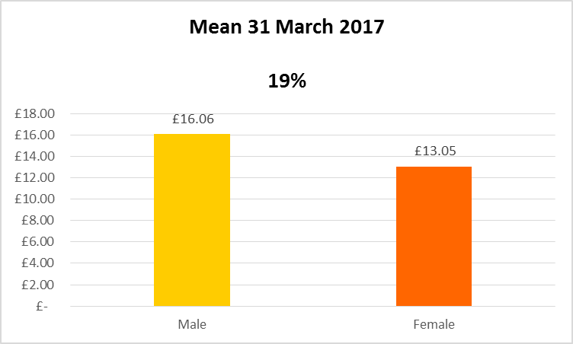

**Median gender pay gap and hourly rate of pay**

**Table 2**

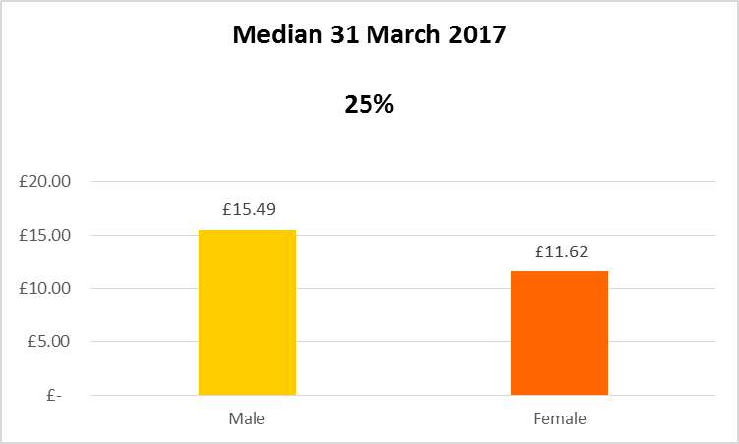

**Bonus gender pay gap**

**Table 3**



**Quartile pay bands (at 31 March 2017)**

**Table 4**

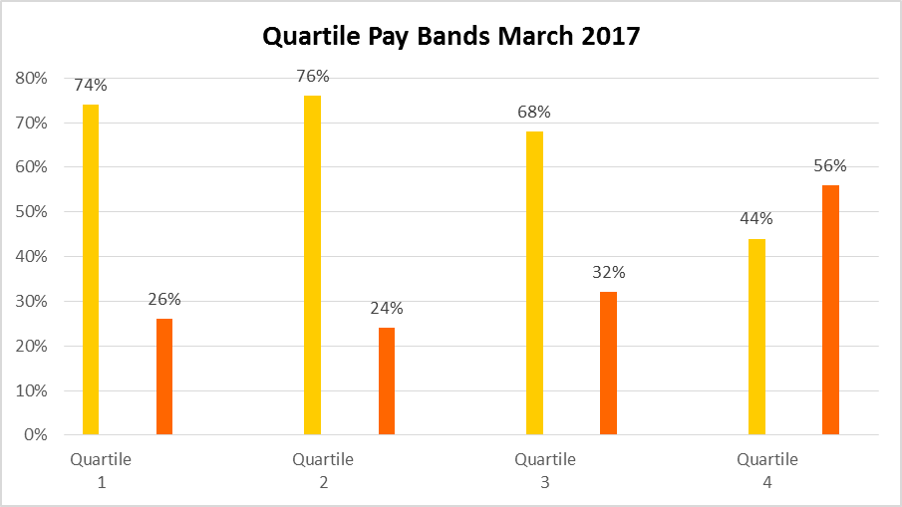



**Analysis of the data**

Tables 1 and 2 – Mean and median gender pay gap

Similar to most areas of local government the Council’s gender split is 66% female and 34% male overall. However, this gender split is not evenly spread throughout all the grades within the Council - as can be seen from the information at

Table 4 the proportion of females is much higher in the lower, lower-middle, upper middle quartiles and this distorts the overall mean and median figures for male and female pay. Within the public sector the gender pay gap for all employees (full and part-time) in the UK in 2017 was 17.4 % (mean) or 18.4 % (median).

Table 3 – Bonus gender pay gap

The Council does not have provision for the payment of bonuses within its terms and conditions.

Table 4 – Quartile pay bands

The proportion of females is much higher in the lower, lower-middle, upper middle quartiles and this distorts the overall mean and median figures for male and female pay.

During the year to March 2017 the profile of new recruits was imbalanced with 83% female recruits and 17% male recruits. In comparison to 79% female leavers and 21 % male leavers.

The Council is committed to the principle of equal opportunities and equal treatment of all employees. We have a clear policy of paying employees equally for the same or equivalent work, regardless of their sex (or any other protected characteristic). As such we have a pay and grading structure agreed with Unison; have a published pay policy statement; evaluate all jobs using North West Employers Organisation (NWEO) Job Evaluation (JE) scheme for chief Officer and the National Joint Council (NJC) job evaluation scheme for all other employees.

The Council is confident that its gender pay gap does not stem from paying men and women differently for the same or equivalent work. Rather its gender pay gap is the result of the roles in which men and women work within the organisation and the salaries that these roles attract.