**GENDER PAY GAP REPORT**

**2022**

# **Introduction**

The Government requires all employers across both the public and private sectors with 250 or more employees to publish their gender pay gap information. The Government’s ambition is to ‘eliminate the gender pay gap within a generation’. Public sector employers are required to publish their information by 30 March, and annually thereafter using a snapshot of the previous March data. Although Allerdale Borough Council has less than 250 employees we have chosen to carry on reporting as good practice.

The regulations require public bodies with over 250 employees to publish six different calculations which show the difference in average earnings (mean and median) for both pay and ‘bonus’ pay between females and males. This information is presented in four pay quartiles each representing a different pay range from the lower pay quartile up to the upper pay quartile. This report details the Council’s Gender Pay Gap figures for the snapshot date of 31 March 2022.

The gender pay gap is not to be confused with equal pay, which is the right for men and women to be paid the same rate when doing the same or equivalent work. The gender pay gap is concerned with differences in the average earnings of men and women, regardless of their role or seniority. It is, therefore, a broader measure capturing not simply any equal pay issues within an organisation, but also any pay inequalities resulting from differences in the sorts of jobs performed by men and women and the gender composition of the workforce by seniority.

Allerdale Borough Council pay men and women the same for doing the same work or work of equal value. The Council has open and transparent pay rates and uses job evaluation schemes and national rates of pay irrespective of who undertakes the work. The Government acknowledges that actions taken to reduce the gender pay gap may take several years and it cannot be assumed that the gap will significantly change year on year.

The gender pay gap shows the differences in average pay between men and women and reflects the variety of roles undertaken across the whole council.

Therefore, some of the causes of a gender pay gap are often outside the control of any one employer.

Whilst the data shows that the Council has a gender pay gap, the Council works hard to ensure that it is fully inclusive and actively encourages a healthy work-life balance and promotes a flexible approach to work to accommodate this. This is reflected in the high level of part-time working across all grades, however mostly by females. The Council promotes diversity, equality of opportunity and choice for our community and employees.

# **Key messages from March 2022 data**

* Allerdale Borough Council is committed to workforce equality and diversity. Males and females who do the same or equivalent roles are paid the same.
* The Council employs a higher proportion of women (66%) than men (34%) and there are more women than men in three of the pay quartiles.
* Of the Council’s top eight salaries in March 2022, two roles were held by females.
* The Council pays the Living Wage Foundation UK Living Wage rate (currently £9.90 per hour) as its minimum wage, and this is higher than many equivalent jobs in the private sector.
* Despite these facts, there is still a slightly wider median gender pay gap at the Council than the national median comparator.
* A plan is in place supporting the workforce to grow their skills, abilities, and confidence. Family friendly flexible working options and employment benefits are also provided such as enhanced annual leave, training, and career progression opportunities. (See Appendix 1).

# **Factors affecting the gender pay gap**

The causes of the gender pay gap are many and varied. They often overlap and are frequently outside the control of any one employer.

An organisation with a higher proportion of men in senior roles and women in junior roles will have a gender pay gap. So too will an organisation with a higher proportion of men than women in better-paid functions such as IT and other science, technology, and engineering roles.

Women also make up three-quarters of the part-time workforce, whose hourly pay rates tend to be significantly lower than those of full-time workers. In addition, women are much more likely to take time out of the labour market for family reasons, slowing the pace at which they typically progress to more senior and better-paid roles.

# **The six gender pay gap figures explained**

The calculations and reasons for the gender pay gaps are complex but as explained previously, are not an indication of unfair or unequal pay.

The regulations are specific about what pay data should and should not be included and which employees should be counted.

The majority of the Council’s workforce are employed under the same terms, conditions and pay and grading structure. There are however various pay elements within this framework which reflects the different types of jobs undertaken and different ways of working, such as payments for shift working and weekend working.

There is also a smaller group of employees who are employed under different terms such as the Chief Officers.

# **Workforce Summary**

The Council had 226 employees during the snapshot period of March 2022.

Nationally local government employs over 1.5 million people – 78% of these are females.

**At ABC:** The total workforce comprised of 226 employees during the snapshot period of March 2022.

## **Figure 1: Gender breakdown of the workforce**

## **Figure 2: Gender breakdown of part time and full time employees**

# **What we have to report**

**Mean gender pay gap:** the difference between the mean hourly rate of pay of male full-pay relevant employees and that of female full-pay relevant employees.

**Median gender pay gap:** the difference between the median hourly rate of pay of male full-pay relevant employees and that of female full-pay relevant employees.

**Mean bonus gap:** The difference between the mean bonus paid to male relevant employees and that paid to female relevant employees.

**Median bonus gap:** The difference between the median bonus paid to male relevant employees and that paid to female relevant employees.

**Bonus proportions:** The proportions of male and female relevant employees who were paid bonus pay during the relevant period.

**Quartile pay bands:** The proportions of male and female full-pay relevant employees in the lower, lower-middle, upper middle and upper quartile pay bands.

# **Gender Pay Gap at 31 March 2022**

## **Figure 3: Mean gender pay gap at 31 March 2022**

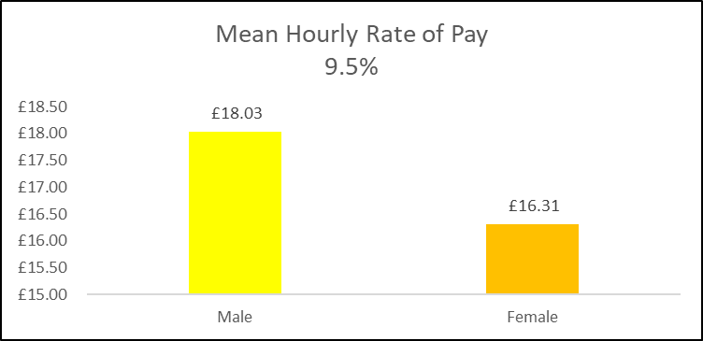

## **Figure 4: Median gender pay gap at 31 March 2022**

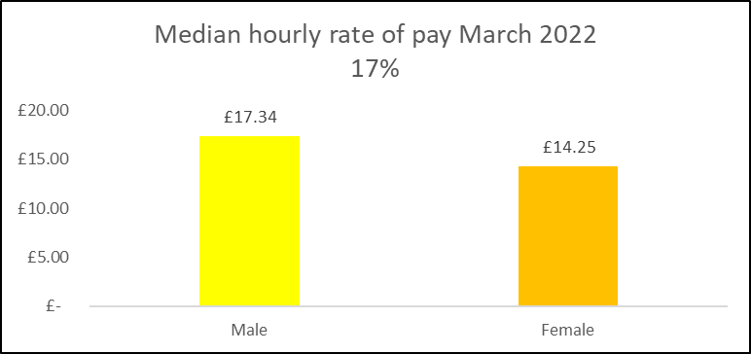

## **Table 1: Bonus gender pay gap at 31 March 2022**



## **Table 2: Quartile pay bands at 31 March 2022**

|  |  |  |  |
| --- | --- | --- | --- |
| **Quartile** | **Males** | **Females** | **Description** |
| 1 | 20% | 80% | Includes all employees whose standard hourly rate places them at or below the lower quartile. |
| 2 | 33% | 67% | Includes all employees whose standard hourly rate places them above the lower quartile but at or below the median. |
| 3 | 33% | 67% | Includes all employees whose standard hourly rate places them above the median but at or below the upper quartile. |
| 4 | 50% | 50% | Includes all employees whose standard hourly rate places them above the upper quartile. |

# **Comparison of mean and median pay gap over time**

## **Figure 5: Mean hourly pay rate comparison**

## **Figure 6: Median hourly pay rate comparison**

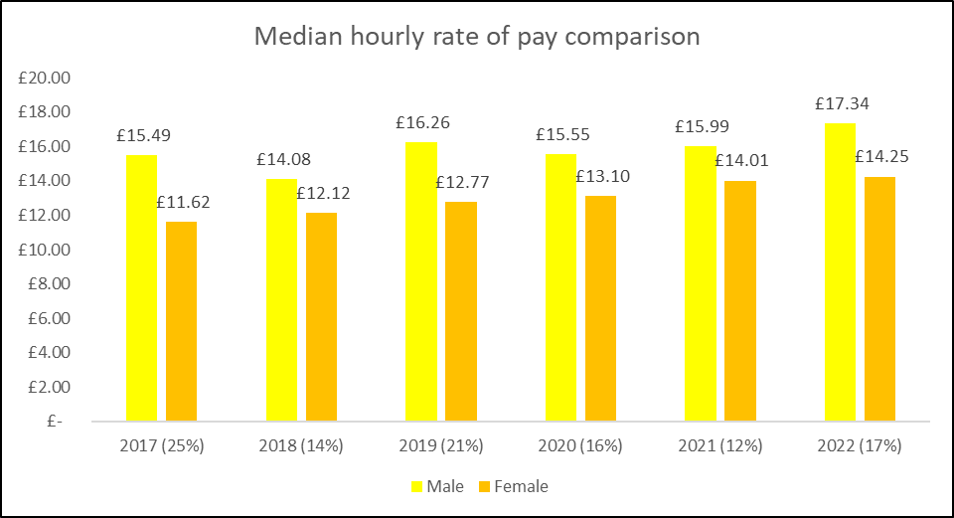

## **Table 3: Comparison of quartiles**

## **Analysis of the data**

Figure 1 shows that the Council’s gender split is 66% female and 34% male overall (similar proportions to those seen across most areas of local government).

Figure 2 shows the breakdown of part-time/fulltime by gender. However, this gender split is not evenly spread throughout all the grades within the Council - as can be seen from the information at Table 2 which shows that the proportion of females is much higher in the lower, lower-middle, upper middle quartiles and this distorts the overall mean and median figures for male and female pay. (Figures 3 and 4).

The Council does not have provision for the payment of bonuses within its terms and conditions. (Table 1)

During the year to March 2022 the profile of new recruits was slightly imbalanced with 45% female recruits and 55% male recruits. In contrast there were 65% female leavers and 35% male leavers.

In comparison to last year’s published figures there has been a positive change to the gender pay gap which can be seen in the mean hourly rate of pay, however the median hourly rate of pay figures showing that the gender pay gap has increased.

# **The underlying causes of a gender pay gap**

There is no legal requirement for employers to publish a narrative explaining their gender pay gap figures, however it is useful to include some information to reflect on possible causes for this.

* Women are more likely than men to have had breaks from work that have affected their careers
* Women are more likely to work part time and many of the jobs available across the UK on a part-time basis are relatively low paid.
* In the wider society it is still often women that undertake caring responsibilities which might make part-time working more attractive even though flexible working practices are also applicable for many higher paid posts in the Council

# **What is Allerdale Borough Council doing to address its gender pay gap?**

Allerdale Borough Council is committed to the principle of equal opportunities and equal treatment of all employees. We have a clear policy of paying employees equally for the same or equivalent work, regardless of their sex (or any other protected characteristic). As such we have a pay and grading structure agreed with Unison; have a published pay policy statement; evaluate all jobs using the Northwest Employers Organisation (NWEO) Job Evaluation (JE) scheme for Chief Officers and the National Joint Council (NJC) job evaluation scheme for all other employees to ensure a fair and consistent pay structure.

Allerdale Borough Council is therefore confident that its gender pay gap does not stem from paying men and women differently for the same or equivalent work. Rather its gender pay gap is the result of the roles in which men and women work within the organisation and the salaries that these roles attract.

The Council is not complacent in looking at ways to reduce the gap, and it is committed to further reducing the gap.

# **Appendix 1**

|  |  |  |
| --- | --- | --- |
| Closing the Gender Pay Gap Action Plan  June 2022 | | |
| **Action** | | **Timeframe** |
| **Data Transparency** | | |
| 1 | Continue to analyse and publish transparent, clear, and detailed workforce information including information on the gender pay gap. | Every 12 months |
| 2 | Review and internally publish a staff survey data on female staff experience to identify any issues to address them. | Every 12 months |
| **Flexible working and family friendly benefits** | | |
| 3 | Continue offering, promoting, and publicising the full range of flexible working to all ABC staff and to new entrants through all appropriate media to raise awareness of their range and availability. All recruiting managers to continue to consider flexible working at the staff hiring stage. | In place - ongoing and monitoring |
| 4 | Support senior and line managers to further improve consistency of access to flexible working across different teams, monitor take up and staff perceptions about availability of flexible working in the staff engagement survey and act as appropriate, for example training interventions. | Ongoing.  Survey in place for every 2 years |
| **Inclusive leadership and unconscious bias** | | |
| 5 | All interview panels to be gender diverse, trained in best practice in recruitment, including countering discrimination and unconscious bias. | In place -ongoing and monitoring |
| 6 | Implement and monitor the impact of ‘no name’ applications forms. | Has been trialled. |
| 7 | Include an unconscious bias script/reminder in the interview pack for recruiting managers, to ensure bias/how to minimise it is front of mind. | In place -ongoing and monitoring |
| 8 | Roll out unconscious bias learning to all staff | Ongoing |
| 9 | Encourage and monitor take-up of mandatory Diversity and Inclusion training to further minimise discrimination, inappropriate behaviours, and unconscious bias occurrence in the workplace. Offer team-based refresher training where appropriate. | Ongoing |
| **Career development – timeframes required** | | |
| 10 | Continue to expand the mentoring, career advice/coaching offer and career development programmes by allocating funding for women and promote it in the organisation to maximise take up. | Ongoing |
| 11 | Offer access to external mentors through initiatives like Women’s Sponsorship Initiative and prioritise access to middle and senior manager level female staff. | Ongoing |
| 12 | Produce regular updates as part of the Workforce Report on take-up of development opportunities by gender and other equality strands. Include breakdown by permanent/fixed term contracts to see if staff on fixed term contracts are not adversely affected. Where appropriate, extend development opportunities available to permanent staff, to staff on short term contracts. | Ongoing |
| 13 | Provide leadership and management development programmes to establish a talent pipeline for leaders and managers of the future. Monitor resulting promotions and other impact on career development. | Ongoing |
| 14 | Review and strengthen succession planning and  talent management processes which together will  lead to an effective career development process for  senior roles. | Ongoing |
| 15 | Review our policies and practice around additional  payments to ensure it is fair and transparent and that  women, and other groups are not disadvantaged. | Ongoing |
| **Senior level recruitment** | | |
| 16 | All senior recruitment campaigns to aim for balanced shortlists. | Ongoing |
| **Workforce Transparency** | | |
| 17 | Review our HR policies and their application in line with best practice to ensure consistency – prioritising those that are likely to impact most - so that all staff (including women) are not disadvantaged in recruitment, selection career progression and reward. Develop performance measures to evaluate the effect of this work. | On-going |
| **Recruitment** | | |
| 18 | Maximise an employer to prospective employees our values to attract more external women applicants from a range of backgrounds for jobs in particular at senior level in order to create a diverse workforce. | Ongoing |
| 19 | Continue to improve capability in flexible job design and building flexible career pathways. | Ongoing |
| 20 | Encourage and monitor take-up of mandatory Diversity and Inclusion training | Ongoing |
| **Encourage the uptake of Shared Parental Leave** | | |
| 21 | * Offer enhanced Shared Parental Pay at the same level as enhanced maternity pay * Encourage take up of Shared Parental Leave * For example: - Inform future fathers that it’s their legal right to request Shared Parental Leave * Provide future parents guidance and personal support to understand the scheme * Share and promote examples of staff who have taken Shared Parental Leave in the Council | In progress |
| **Recruit Returners** | | |
| 22 | Returners are people who have taken an extended career break for caring or other reasons and who are either not currently employed or are working in roles for which they are over-qualified.  For example:   * Target places where returners are likely to be looking * Ensure the recruitment process is returner-friendly * Offer support before and during the assessment | To be reviewed |