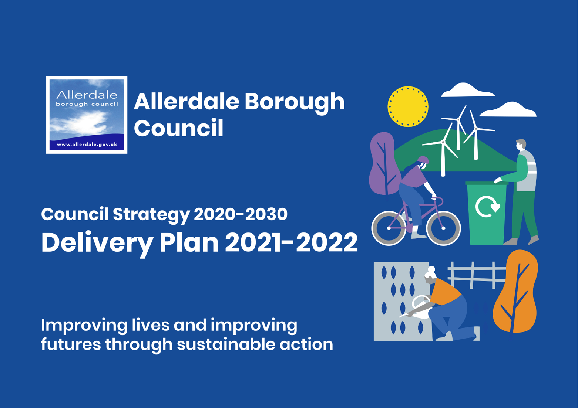

Introduction

Our Council Strategy shapes everything we do. Our Council Strategy 2020-30 sets the strategic direction for our Council to 2030. It describes the outcomes we would like to achieve for our communities and gives an overview of the kinds of activity we will undertake to achieve those outcomes.

In 2020 the Council determined to develop an Interim Delivery Plan due to the uncertain impact that the pandemic would have on the Council and the area. Unfortunately the Council finds itself planning for 2021 in the continued midst of the pandemic and has therefore determined to develop a further one year Delivery Plan for 2021/22.

Our overall long term strategic direction does not need to fundamentally alter at this point, but we do need to shift our focus in the shorter term. In the very short term we are focussed on supporting our communities and businesses through the continuing crisis, making sure that people can get the services and support that they need from us. As we move into a transition and recovery phase we will need to develop dynamic approaches to support our communities and help our economy rebuild, whilst at the same time making sure that our organisation is stable and our services are running as effectively as possible. Whilst it is difficult to place any precise timescales on recovery - the phasing of the recovery will be influenced by national policy decisions that the Government makes over the coming months – we recognise how important it is that we start to map out recovery activities, as well as continuing to deliver any immediate response effectively.

Like last year this Delivery Plan is written to cover the next 12 months only. Once more this will allow us to develop our understanding of the impacts of the pandemic and how the Council may have to shape services over the coming years. Therefore, the Council has chosen to be focussed on supporting the response and recovery from the pandemic in the short term whilst retaining flexibility to respond to the needs of the community in the years to come.

This Delivery Plan follows the six priorities set out in the Council Strategy:
• A financially secure council
• A cleaner, greener Allerdale
• Invest to grow
• Outstanding local services
• Thriving towns and villages
• Resilient communities
For each priority we set out key projects that we need to keep on track over the coming year, key service and strategic activity that will need focus over the next year, and key performance measures focused on the effective delivery of our services.

A financially secure council
Our objectives: Address the projected budget gap • Become self-sufficient by 2030 • Become more commercial • Become more efficient and productive
A key focus over the coming months will continue to be managing the impact that the Covid-19 pandemic has had and will continue to have on the Council’s finances and building that understanding into our future financial projections and plans. This will include analysing the impacts on the Council’s income streams with a focus on restoring income streams and developing new streams where appropriate. The Covid-19 crisis has placed even more pressure on our finances and highlights even further the importance of achieving efficiency and effectiveness in the delivery of our functions and finding ways to improve our resilience through additional sources of income. Key activity for this year will also include implementing a range of improvements that will enhance the operation of the Council going forward, building on the success and learning from our experiences of operating and using technology differently during the Covid-19 lockdown period. This work includes considering the sustainability of new ways of working that have been developed during the response to Covid-19 and ensuring resources are aligned to maintain high levels of performance for our customers.

Key projects/activities | Timescales | Responsible Officer
Local Government Reorganisation in Cumbria – continue to engage with the Government further to the conclusion of the consultation process where necessary | Ongoing | Chief Executive
Review the Target Operating Model and working practices as part of our recovery strategy and implement changes in staffing structures and accommodation strategy | September 2021 | Assistant Chief Exec (Innovation and Commercial)
Continue a programme of service reviews across the council looking at cost, quality and delivery mechanisms (building in learning from operating during the pandemic) - waste services and car parking will be prioritised for review | Ongoing | Assistant Chief Exec (Innovation and Commercial)
Review the Council’s procurement regime - especially in light of EU withdrawal and changes to the subsidy scheme | October 2021 | Assistant Chief Exec (Innovation and Commercial)
Introduce new outdoor markets to provide an opportunity for new entrepreneurs, provide a service to residents and generate new council income | September 2021 | Programme Director (Workington)

Strategic planning | Timescales | Responsible Officer
Develop a financially secure strategy that provides a roadmap to self-sufficiency and builds on the Council’s transformation programme | November 2021 | Chief Officer (Assets)/ Assistant Chief Executive (Policy, Performance and Economic Strategy)
Review the council’s property and asset management strategy | October 2021 | Chief Officer (Assets)
Identify areas of collaboration with other local authorities especially in areas such as nuclear and tourism | Ongoing | Chief Executive

Key performance indicators | Frequency | Target 2021/22
% of council income that is from grants, CTtax, NNDR, fees and charges (including commercial income streams) | Annual | Aiming to reduce reliance on grants over longer term
Overall % of budget coming from balances | Annual | Aiming to reduce over longer term
Level of forecast budget gap | Annual | Aiming to reduce over longer term
% of debt outstanding for over 90 days | Monthly | A reducing trend through the year
NNDR collection rate | Monthly | 97.70%
Council Tax collection rate | Monthly | 97.20%
Occupancy rates of Council’s property portfolio | Monthly | 90%

A cleaner, greener Allerdale
Our objectives: Make sure our neighbourhoods are clean and tidy • Reduce waste and increase recycling • Improve and protect our open spaces and green infrastructure • Ensure environmental sustainability is at the heart of our policies • Use our assets to encourage green technology

We have clear objectives around waste, recycling and neighbourhood cleanliness. We aim to provide our waste and recycling services as effectively as possible whilst addressing issues with increased waste to landfill and increased fly tipping seen during the pandemic period. The past year has highlighted even more the importance of our open spaces and green infrastructure for everyone to enjoy for exercise and wellbeing – we will continue to make sure our neighbourhoods and open spaces are clean, tidy and safe, take enforcement action where necessary, and work to improve and protect those spaces. It is also important to maintain focus on the wider environmental agenda and look for opportunities as we move into recovery, so we aim to progress work on biodiversity and on delivering our Climate Change Action Plan.

Key projects/activities | Timescales | Responsible Officer
Tackle and reduce fly tipping through enforcement action and educational activity focusing resources on known hotspots | Ongoing | Chief Officer (Place and Governance)
Carry out recycling initiatives and educational campaigns to reduce waste | Ongoing | Chief Officer (Assets)
Progress strategic green infrastructure and biodiversity projects and encourage environmental volunteering: : Water Environment Grant projects at Siddick Pond; Northside  allotment improvements; Workington Nature Partnership projects; development of 'Get Cumbria  Buzzing' sites (12 sites) | Northside 2021  Other projects by 2022 | Chief Officer (Assets)
Implementation of a revised climate change action plan; this will include establishing a carbon baseline for our buildings and carbon literacy training for members and officers | Ongoing | Assistant Chief Executive (Policy, Performance and Economic Strategy)

Strategic planning | Timescales | Responsible Officer
Consider a full range of options on the future of waste collections | September 2021 | Chief Officer (Assets)
Biodiversity Supplementary Planning document to be developed | December 2021 | Assistant Chief Executive (Policy, Performance and Economic Strategy)

Key performance indicators | Frequency | Target 2021/22
Number of fly tipping incidents | Monthly | Aim to reduce through the year
Number of Fixed Penalty Notices issued (fly tipping) | Quarterly | Aim to increase through the year
% of household waste sent for reuse, recycling and composting | Quarterly | 37%
Residual waste per household (kgs) | Quarterly | 479kg
% of bins collected as scheduled | Monthly | 99.92%

Invest to grow

Our objectives: Use our asset portfolio to create new or different opportunities • Work with partners on key economic sites and opportunities • Utilise the Allerdale Investment Partnership, the Local Enterprise Partnership and Britain’s Energy Coast to stimulate growth • Develop a housing company to provide the right homes in the right places at the right price

The Covid-19 crisis has hit our local, national (and global) economies very hard and the repercussions are likely to be felt for years to come. Our role will be to provide opportunities, assistance, support and leadership to help our area fulfil its potential. It is vital that in the short term we do all we can to support local businesses and employers and stabilise the local economy, but we also need to look to the future to help create the conditions to stimulate investment and development in Allerdale. Working with partners we need to create recovery plans that aim to develop a more inclusive, resilient and green economy in the longer term, and help Cumbrian businesses to take advantage of opportunities to diversify and enter new market segments. A key activity to support this work will be an ongoing assessment of intelligence and information to help us better understand the impacts on the borough, for example how quickly and to what extent supply and demand returns, as we move through exit phases from the current lockdown.

Key projects/activities | Timescales | Responsible Officer
Deliver the national programmes of support grants to businesses, including developing and delivering any discretionary schemes to support local businesses | Ongoing | Chief Officer (Assets)/ Assistant Chief Executive (Policy, Performance and Economic Strategy)
Further development of the Housing Company, including the review of growth opportunities with key partners and, successfully delivering the programme of works to 18 Otley Road, Keswick | Ongoing | Programme Director (Maryport)
Work with AIP and BEC on key strategic sites and delivery of projects in key regeneration programmes | Ongoing | Assistant Chief Executive (Innovation and Commercial)
Deliver the Lillyhall North Infrastructure Project | December 2021 | Assistant Chief Executive (Innovation and Commercial)
Deliver the Self-Build Custom House Building grant-funding programme to support individuals and communities to deliver more homes | Ongoing | Assistant Chief Executive (Policy, Performance and Economic Strategy)

Strategic planning | Timescales | Responsible Officer
Collaborate with Cumbria County Council and Cumbria Local Enterprise Partnership on land at Oldside and potential developments at the Port of Workington | Ongoing | Programme Director (Workington)

Key performance indicators | Frequency | Target 2021/22
% of major planning applications determined within statutory period | Quarterly | 90%

Outstanding local services
Our objectives: Make it easy for customers to contact us • Ensure we get it right first time • Be bold in our use of technology • Look at different and better ways to deliver services

We have successfully managed to keep our essential services running well throughout the Covid-19 crisis period, as well as taking on additional tasks asked of us by national government to provide support to our businesses and communities. Part of our success has been rooted in our previous work to enable digital delivery of services and a mobile workforce which will continue to be important going forward and we will be building learning from the current period into future working practices. We have seen changing demand for some of our services during the initial crisis phase (both increases and decreases) and we will need to plan for the year in terms of projected ongoing changes in demand. A few of our services have been forced to cease under Covid-19 restrictions and there will be work to do over the next weeks and months to make sure they can successfully resume. Departments will be working to develop service-specific recovery plans setting out how phased recovery will work taking into account ongoing demand, risks and changes to working practices. Our aim will be to make sure our services are easy to access, helpful and efficient.

Key projects/activities | Timescales | Responsible Officer
Deliver technology projects in line with the Connected Futures strategy to provide improved digital platforms and self-service options including:  - continued implementation of a cloud based built environment and regulatory services system.  - purchase and implementation of a new finance, payroll and HR system  - choice based lettings implementation | Ongoing | Assistant Chief Executive (Innovation and Commercial)
Effective management and monitoring of the Allerdale Waste Services contract | Ongoing | Chief Officer (Assets)
Monitor and improve the wellbeing of the staff team through staff review process | Ongoing | Chief Executive
Cockermouth cemetery road repairs and creation of 25 new graves | October 2021 | Chief Officer (Assets)
Better business for all – ensure that our regulatory services provide support to businesses in an easy to understand way | Ongoing | Programme Director (Workington)
Ensure that the new Choice Based Lettings policy is introduced successfully in line with the introduction of the new CBL IT system | Ongoing | Assistant Chief Executive (Policy, Performance and Economic Strategy)

Strategic planning | Timescales | Responsible Officer
Consider options around long term planning for cemeteries | March 2022 | Chief Officer (Assets)
Analyse population/demographic challenges and changes that impact on the borough and council | March 2022 | Assistant Chief Executive (Policy, Performance and Economic Strategy)

Key performance indicators | Frequency | Target 2021/22
% of abandoned calls | Monthly | 7%
Customer satisfaction (ring back) | Monthly | 90%
Number of complaints | Monthly | A reducing trend over the year
Facebook engagement rate | Monthly | Average engagement rate of more than 10% over the previous 3 month period
ENewsletter unique opens (external only) | Monthly | 40% open rate
Newsletter subscribers/subscriptions | Monthly | 5% growth month on month
Digital transactions as a % of total transactions | Monthly | 50%
Overall time ICT systems available for use | Monthly | 99.9%

Thriving towns and villages
Our objectives: Support businesses • Create deliverable town plans that enable our towns to adapt to the changing nature of the high street • Ensure there are suitable, affordable, decent homes for all • Give people a reason to visit our towns (festivals, events, cultural and sporting activities, markets) • Increase the number of people living in our town centres • Build communities, not just homes
This is an important area for us, made even more significant in the current circumstances. A key focus over the next months will be on fully understanding the impact that the Covid-19 pandemic has had and will continue to have on our towns, villages and businesses and to build that understanding into our future plans. This will include analysing the impacts on our town centres, the wider business community and the housing market as we move through the different recovery phases the government have now set out. Our high streets were already being impacted by changes in the way we all shop, and there are now a new set of challenges that our businesses will need to adapt to with ongoing restrictions, regulations and changes.
As a council we have a number of service areas that can support businesses with advice and key services, such as planning, building control, licensing and environmental health, and we will make sure we are offering helpful and proactive advice and guidance for businesses. We can also make sure we help to maintain demand in the local economy by using local suppliers where we can and paying local suppliers promptly. Our two big regeneration programmes in Maryport and Workington continue to be vitally important for those towns, and now that we have secured significant funding for these programmes we can move to planning for delivery of projects in 2021/22.

Key projects/activities | Timescales | Responsible Officer
Approval of new economic strategy and implementation of activity | May 2021 and ongoing implementation | Assistant Chief Executive (Policy, Performance and Economic Strategy)
Maryport Regeneration Programme: Following the receipt of Future High Streets funding confirmation in April the aim will be to commence activity on all elements of the programme including Public Realm, Empire Yard, The Carlton, Christchurch, The Wave, residential development and commercial development. In relation to the Heritage Action Zone programme work will continue to develop the Cultural Consortium and its offer for the town and in relation to physical projects, the Town Hall, Maritime Museum, Heron Foods, Crosby Street, shop fronts scheme and public realm works will be progressed. | Ongoing | Programme Director (Maryport)
Workington Town Deal: business case development | Ongoing | Programme Director (Workington)
Continue to develop business engagement and support activity to enable the Council to better understand businesses issues, challenges and ideas and feed those through to local, regional and national forums | Ongoing | Assistant Chief Executive (Policy, Performance and Economic Strategy)
Undertake work with partners to support the recovery of the visitor economy including assessing the impact, considering appropriate interventions and delivering actions as part of a recovery plan for the visitor sector, markets and events | Ongoing | Programme Director (Workington)
Deliver disabled facilities grants and review the Housing Grants and Assistance Policy in light of the pandemic, and agree the outcomes with key partners linked to the Better Care Fund | Ongoing | Chief Officer (Place and Governance)
Grow the visitor economy by implementing an attract and disperse programme in partnership with CLEP visitor economy panel and tactical visitor marketing group | Ongoing | Programme Director (Workington)
Delivery of the Reopening High Streets Safely fund and the Welcome Back fund | Ongoing | Assistant Chief Executive (Policy, Performance and Economic Strategy)

Strategic planning | Timescales | Responsible Officer
Business case development – developing a pipeline of regeneration projects that can be funded through Government programmes such as the Shared Prosperity Fund | Ongoing | Assistant Chief Exec (Innovation and Commercial)
Complete a new housing needs assessment and stock condition survey | March 2022 | Assistant Chief Executive (Policy, Performance and Economic Strategy)

Key performance indicators | Frequency | Target 2021/22
% of invoices from local Cumbrian businesses paid within 14 days | Monthly | 98%
% of all Council spend on goods and services with local Cumbrian suppliers | Quarterly | 50%
Numbers of affordable homes delivered | Quarterly | Not targeted
Full Plans determined within 5 weeks (Building Control) | Monthly | 85%
% of Local Land Charges Searches carried out within 10 working days | Monthly | 98%
% of minor and other planning applications determined within statutory period | Monthly | 90%
No. of housing units granted planning permission | Quarterly | 353
Number of DFGs approved | Monthly | Increase through the year

Resilient communities
Our objectives: Promote healthy, active lifestyles • Address community safety issues • Engage with our communities, and our town and parish councils • Prevent and reduce homelessness • Address inequalities

The pandemic crisis has had a profound impact on our communities and we will continue to see the effects of the crisis for some time to come. Over the coming months we will need to consider how we can help to support our residents and communities across the district as we move out of the current restrictions, in particular how we continue to best support residents at greater risk as we move into recovery. Those at greater risk include residents with specific medical conditions as well as those with wider risk factors including social isolation, domestic abuse, those with low income or in receipt of benefits, those in insecure, low-paid work, and the ageing population.
Our homelessness service is vitally important and there will be much work to do over the next months to address ongoing demand as the economy continues to be hard hit. Making sure there are a range of leisure opportunities for our communities to support health and wellbeing is also a key activity for us and there will be work to do over the coming weeks and months to firstly ensure our leisure centres reopen effectively and secondly to think about leisure provision in the longer term. The Council contributes to existing health and wellbeing, community safety and other networks that will continue to co-ordinate and deliver activity to support our communities such as the Allerdale Health and Wellbeing Forum, the multi-agency Local Focus Hub, and the Allerdale Work and Skills Partnership. The Council will build on and develop existing and new relationships to offer targeted, effective and long term support and assistance, through recovery and beyond. Work to support communities will vary locally across communities within Allerdale using place-based intelligence to identify need.

Key projects/activities | Timescales | Responsible Officer
Work with GLL to plan for reopening and future operation of leisure centres including restarting the Healthwise Scheme to deliver exercise on referral | December 2021 | Chief Officer (Assets)
Deliver a grants pot to support sporting clubs and associations to improve accessibility, participation and to support recovery from impacts of the Coronavirus pandemic | March 2022 | Chief Officer (Assets)
Further develop the Allerdale Local Focus Hub to drive a thriving families approach with existing and new partners including responding to the ongoing impact of lockdown and continued social distancing measures. | Ongoing | Chief Officer (Place and Governance)
Provide advice and guidance, along with undertaking investigation and enforcement activity, to support Covid-19 restrictions on businesses and help them provide safe environments | Ongoing | Chief Officer (Place and Governance)/  Programme Director (Maryport)
Undertake and further develop the wider public health response including the existing track and trace service currently delivered in partnership with Cumbria County Council | Ongoing | Chief Officer (Place and Governance)/  Programme Director (Maryport)
Implement the Resilient Communities Strategy | Ongoing | Assistant Chief Executive (Policy, Performance and Economic Strategy)
Deliver grants and support those experiencing financial hardship including the Council Tax Reduction Scheme and other schemes relating to financial hardship as a result of the pandemic | Ongoing | Chief Officer (Assets)
Review the homelessness service and implement the Homeless Strategy action plan including a focus on prevention activity and ongoing work to help the additional people housed during the pandemic crisis period to remain in accommodation | Ongoing | Chief Officer (Place and Governance)
Deliver the Resilient Communities Fund – allocation of resources to support the community sector | March 2022 | Assistant Chief Executive (Policy, Performance and Economic Strategy)
Continue to build strong linkages with key community organisations | Ongoing | Chief Executive
Complete the commission for the Gypsy and Traveller Accommodation Assessment (GTAA) and evaluate the outcome of the GTAA against the site allocation in the Local Plan Part 2 and commission a review of the design study to reflect the new identified need. | September 2021 | Assistant Chief Executive (Policy, Performance and Economic Strategy)

Strategic Planning | Timescales | Responsible Officer
Develop options for future provision of leisure services | March 2022 | Chief Officer (Assets)
Review the Council’s approach to safeguarding and corporate parenting | December 2021 | Chief Executive

Key performance indicators | Frequency | Target 2021/22
Leisure centre usage | Monthly | Aiming to increase gradually once centres can reopen
% of homeless decisions made within guideline 56 days | Quarterly | 100%
% of successful homeless preventions and relief outcomes | Quarterly | 50%
Time taken to process Housing Benefit new claims (no. of days) | Monthly | 15 days
Time taken to process Council Tax new claims (no. of days) | Monthly | 20 days
Time taken to process Housing Benefit/Council Tax change of circumstances (no. of days) | Monthly | 4 days

